Proposal for HM Prison and Probation Service
VCSE Commissioning 2023
About YMCA Milton Keynes
YMCA Milton Keynes has been established since 1981 and in that time has supported over 10,000 young people aged 18-35 through emergency accommodation and supported housing. We are the largest provider of dedicated supported housing to young people in Milton Keynes. We work with young people who have experienced homelessness and provide them with, not only a safe place to stay, but a range of support services that empower them to belong, contribute and thrive.
Our existing core service achieves strong outcomes for young people in Milton Keynes. Last year, we supported 300 young people via our new campus and move-on accommodation. 96 of those young people were new residents to our campus. Despite the significant impact of the pandemic, 99 young people were supported into sustained employment last year. Since March, we have supported 74 young people into employment this year so far.

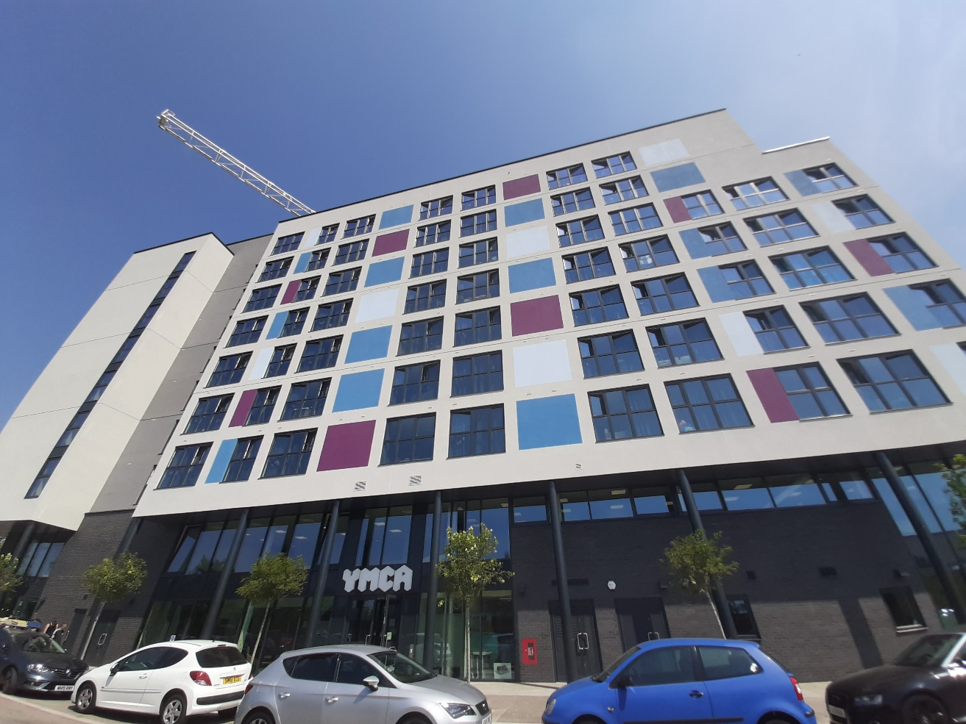
YMCA Milton Keynes £18.5 million development in central Milton Keynes

Our Resident Community
The University of Northampton independently reviewed YMCA Milton Keynes & its services and produced the following data. These statistics are constantly in flux because we have a transient resident community of up to 242 young people but will give a general overview of the level of needs our services meet:
- 66% of residents were homeless before coming to the YMCA
- 27% of our residents are Black & Minority Ethnic (BAME)
- 13% of our residents are LGBTQIA+ (a total of 27 young people currently) of which 3% identify as transgender
- 60% of our resident’s class themselves as having a disability, predominately due to mental health issues
- 50% of our residents report a background of trauma
- 54% of our residents have been victims of domestic abuse
- 45% of our residents have been involved with the criminal justice system
- From our own data, we know that in the last 12 months 8 male residents and 6 female residents have attempted suicide

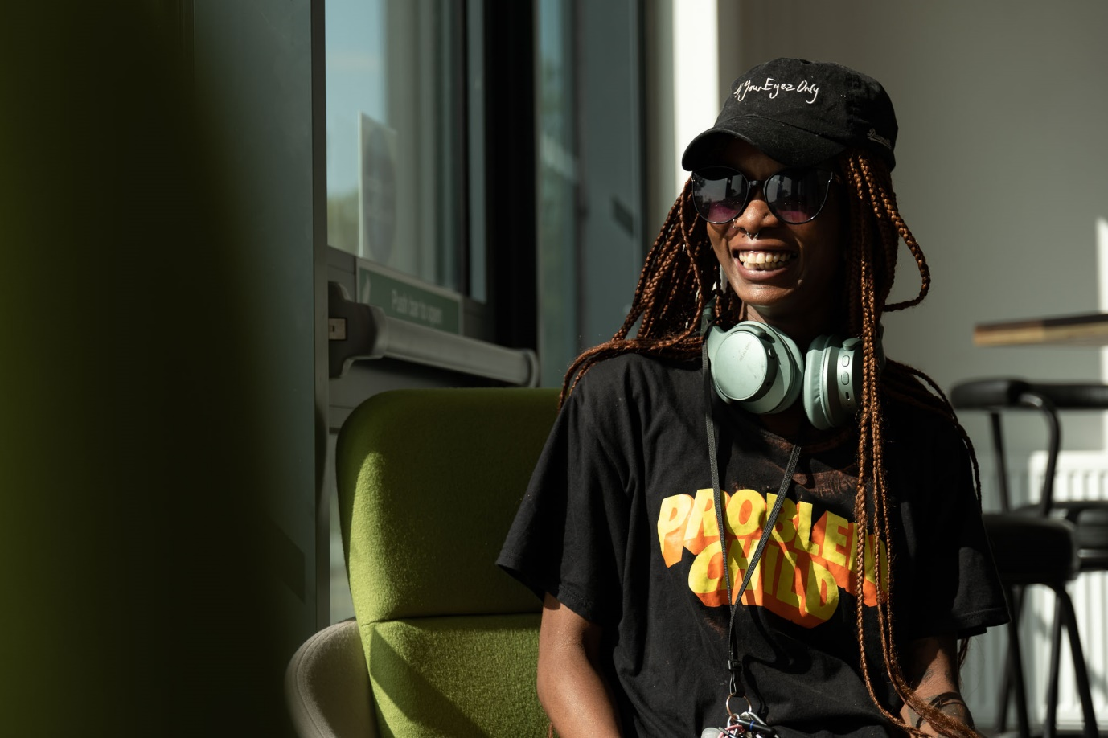
Many of our residents have multiple complex needs which are a unique combination of the varied experiences highlighted above.

Our Young People and the Criminal Justice System
Our team is experienced at working with young people who have experienced the criminal justice system and recognise that these young people have additional complexities and support requirements. We would like to provide them with an additional specialist tailored support offer with your help.
In October 2021 we began to record young people joining us with criminal justice system involvement and those with criminal convictions.
Since then, 101 young people aged 18-25 years moved into YMCA. Of those:
- 24 young people have experience of the criminal justice system (24%)
- 10 young people have a criminal conviction (10%)

Since then, 145 young people aged 18-35 years moved into YMCA. Of those:
- 44 young people have experience of the criminal justice system (30%)
- 18 young people have a criminal conviction (12%)

As young people voluntarily disclose details to YMCA, and we prioritise building a positive relationship over forcing them to share personal information, these numbers are likely to be significantly higher in reality. Working with the HM Prison and Probation Service, we would like to increase the data we record and the support we offer to this cohort during their time at YMCA.

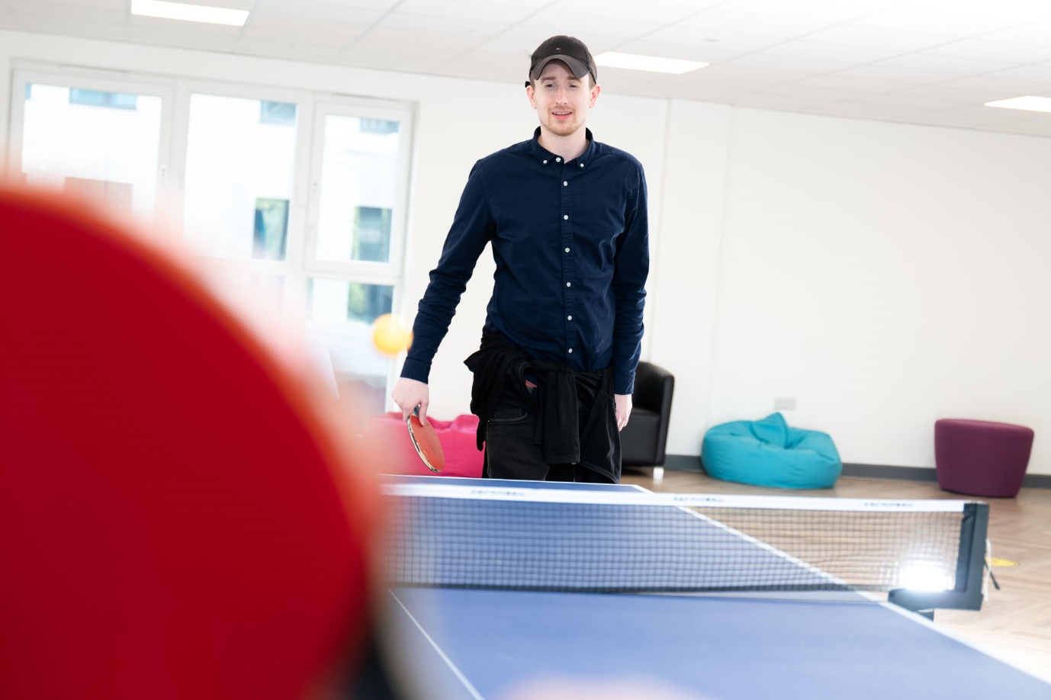
Our Approach
At YMCA Milton Keynes, all services are delivered from an asset-based perspective, ensuring that staff focus on young people’s existing and innate abilities and qualities, rather than simply the challenges they face.

This is particularly important with young people, especially those leaving the criminal justice system, many of whom have experienced significant trauma. It is crucial that the support provided does not focus on individual’s ‘weaknesses’, compounding issues such as low self-esteem, but instead focuses on their existing assets and how we can build on these together. This is a popular and well-evidenced approach throughout homelessness services.

All of this work is under-pinned by an Emotional Needs framework so that our support work is focused first and foremost on creating emotionally healthy young people. We believe that emotionally healthy young people will then take steps to effectively manage their own affairs, with our ongoing support.

We believe that the following specific emotional needs are core drivers for our behaviour. This is modelled on the Human Givens school of psychotherapy.
- Security: Safe territory and an environment which allows us to develop fully.
- Attention: (to give and to receive) – a form of nutrition
- Sense of autonomy and control: having volition to make responsible choices
- Emotional intimacy: to know that at least one other person accepts us totally for who we are ‘Warts and all’.
- Feeling part of a wider community – connection to people outside our immediate family through work, hobbies, sport, geographical and cultural communities.
- Privacy –opportunity to reflect and consolidate.
- Sense of Status within social groupings – a sense of being accepted, valued, and having status within our group.
- Sense of competence and achievement – a sense of our own abilities, knowledge, and skills.
- Meaning and Purpose – which come stretched mentally and physically and having purpose in what we do.
(Human Givens Institute)

These needs will be considered throughout all three stages of accommodation. For example, there are no shared bedrooms or bathrooms within any stage of our accommodation, providing privacy.
Continually working with young people towards emotional well-being will be essential to ensure that they have the resilience to move forward into training, employment, and independent accommodation.

Our Housing Pathway
In order to meet the complex and varied needs identified above, it is important that we are able to offer a personalised pathway of support. In addition, we utilise a trauma-informed and asset-based approach across all that we do.
YMCA Milton Keynes
Our pathway is set over three stages at our central Milton Keynes campus:
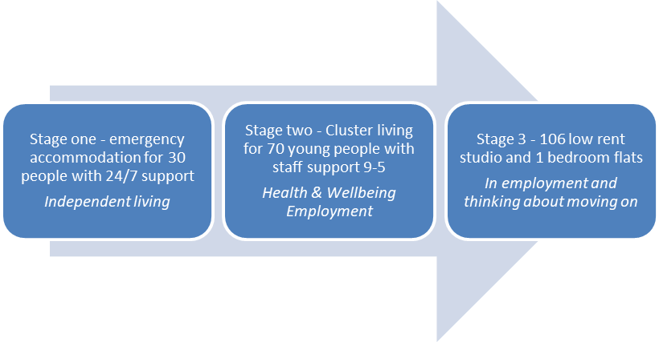
- Stage One: The first stage of our housing pathway provides supported accommodation for 30 residents. In Stage One, residents have weekly structured support sessions with their dedicated Supported Housing Coach focused on their identified support needs. Support sessions are focused on improving the physical and emotional wellbeing of our young people. In addition, we provide practical support in areas such as living independently through our Independent Living Skills programme, budgeting, and money management amongst others. Our Stage One accommodation is comprised of 30 bedrooms with single bed and ensuite and all 30 rooms share a large communal kitchen & living room area.
- Stage Two: Once a resident has been working on their support needs and is making progress, to the extent they are ready to begin engaging with education and/or employment activities then they are ready to move to our stage 2 of accommodation. In Stage Two our young people will live on a communal floor, designed to mimic a university campus layout. They will have a room with double bed and ensuite and will share a kitchen/ living room with the other rooms on their floor. In Stage Two, residents will continue to have regular structured support sessions to address their non-employment support needs.
- Stage Three: Our third stage of accommodation is comprised of independent, affordable rent flats either 1-bedroom or studio in design. Residents of Stage Three must be in employment and can enter this stage without having gone through our pathway. Where they have come through our housing pathway; once a resident has been in employment for eight weeks, they can move into Stage Three. In Stage Three, residents do not partake in regular support sessions, but have a named Supported Housing Coach if they need a little extra helping hand.

Employment and Activities Programme
YMCA Milton Keynes has its own inhouse employment team who predominantly support residents in Stage Two but are available to all residents.
Despite the significant impact of the pandemic, 99 young people were supported into sustained employment last year. Since March, the team have supported 74 young people into employment this year so far.
In addition we have two Activities Co-ordinators who provide a range of activities, physical and therapeutic, on site specifically designed to upskill young people in these areas and to create emotionally healthy young people who will engage in education and employment and go on to lead happy and healthy lives.
Additional Support
Throughout all three stages of the pathway of support, residents have access to mental wellbeing support. We have a dedicated mental wellbeing suite, where residents can access counselling services with qualified counsellors who are trained in supporting young people who have experienced trauma.
We work with local counselling offers, such as IAPT and YiS Young People’s Mental Health, to provide free counselling and mental health support to all of our residents for a period of 6-8 weeks. This can be extended in certain cases when agreed by the resident and their counsellor.
We have recently applied to the National Lottery to develop our inhouse mental health offer which, if successful, would include a Mental Health Assessment process for all new residents, access to a Psychologist and wider clinical team on site to support with quick diagnosis and access to treatment, and the creation of a new Youth Mental Health Hub available to all young people across Milton Keynes.
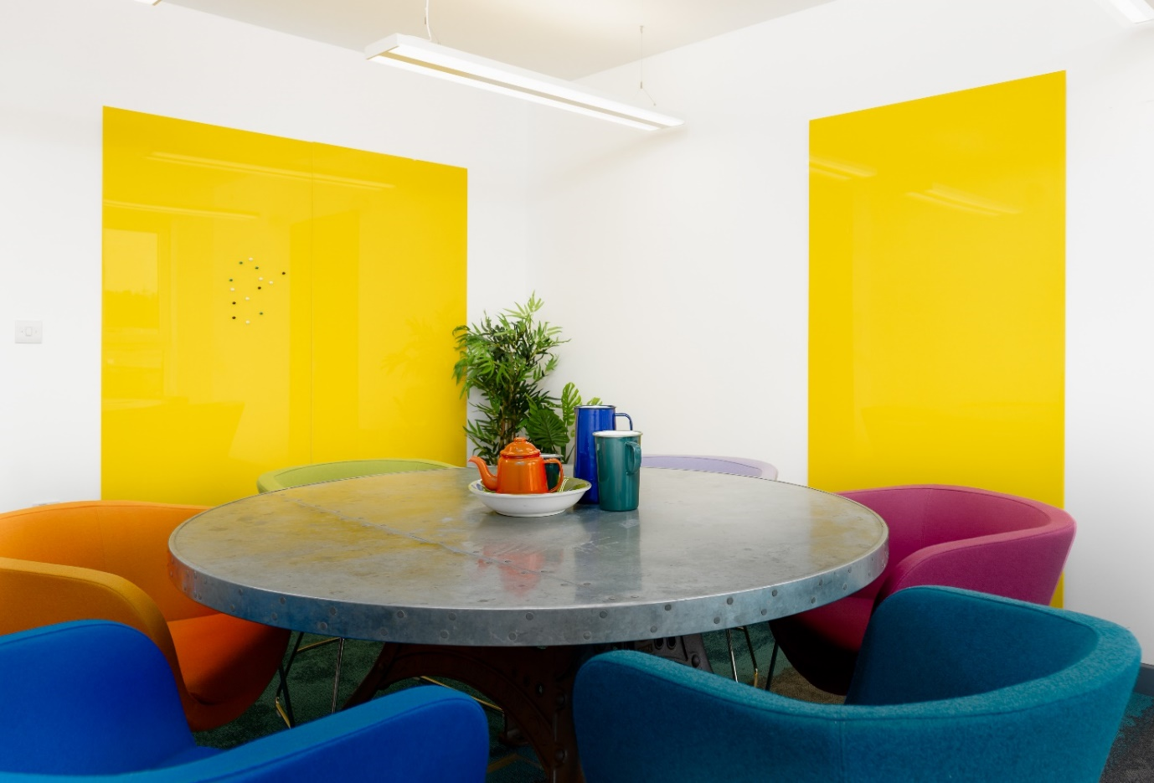
The Benjafield Suite where our residents receive support
Our Proposal
We would like to work closely in partnership with HM Prison and Probation Service to provide additional support to young people with experience of the criminal justice system during their time at YMCA.
We have broken our offer down into three distinct asks for you to select from:
Item | Cost
Consultation & Report | £5,000
InForm Development Package | £4,885
Criminal Justice Lead | £11,317
TOTAL | £21,202

Please find more details on each ask outlined below:

Consultation with Report
We recently completed a consultation and report for the BLMK Integrated Care Board regarding our residents’ views on Health Inequalities as part of the Denny Review. We spoke to 47 residents and produced a 30-page report outlining their thoughts, views, and suggestions for service improvements to guide local public health commissioners in their future decision making.

After our initial discussion, we propose that we deliver a similar consultation exercise on behalf of HM Prison and Probation service with young people aged 18-35 with experience of the criminal justice system with a particular focus on those with criminal convictions that live with us at YMCA. We work in a trauma informed and person-centred way so we will approach and ask young people about key themes of interest outlined by the HM Prison and Probation Service and then share their direct feedback with you in a comprehensive written report to guide and include youth voice in your future commissioning decisions.

Proposed Costs
Please find our cost proposal for the consultation with report outlined below:
Item | Cost
Staff Costs | £3,000
Operational Costs (room hire, refreshments, overheads etc.) | £1,250
Evaluation and Reporting | £750
TOTAL | £5,000

InForm Development Package
YMCA Milton Keynes use In-form as our resident relationship and service management system. In-Form is designed to support our staff team to build stronger relationships with our residents and to improve the productivity of our services. In-Form also allows us to track and record the work that we deliver, and to generate evidence-based data that we can share with our funders and commissioners.
We would like to work with HM Prison and Probation Service to determine which evidence-based quantitative and qualitative data you’d like us to collect regarding young people with experience of the criminal justice system to support future commissioning at YMCA. We currently collect whether young people have experience of the criminal justice system and whether they have a criminal conviction, but our reporting could be more comprehensive in this area.
Proposed Costs
Please find our cost proposal to allow a specialist to update InForm with agreed requirements outlined below:
Item | Cost
5 x InForm Build Days (£977 per day) | £4,885
TOTAL | £4,885

Criminal Justice System Lead
Recognising the specialist needs of young people who have experience of the criminal justice system, we recently recruited a Criminal Justice System Lead into our Supported Housing team to provide tailored support to this cohort. One third of their time is dedicated to this work so we’d ask you to cover one third of their salary plus on costs.
This Lead will work directly with young people who have experience of the criminal justice system at YMCA in a person-centred and trauma-informed way to allow the individual to set and achieve their own goals for the future and to move them forward. They will connect them with our internal Employment & Activities offer outlined above and the Ingeus employment support commissioned by HM Prison and Probation Service alongside other relevant external agencies and encourage their attendance and engagement at these sessions.
Proposed Costs
Please find our cost proposal to allow a specialist to update InForm with agreed requirements outlined below:
Item | Cost
Criminal Justice Lead (Salary: £28,280 + 20.05% oncosts)  - One third of their dedicated time (33%) | £11,317
TOTAL | £11,317

If you have any further questions regarding this proposal, please contact Kat Newman at kat.newman@mkymca.com or call 01908 295 600

